SEDCO

User Manual

# This manual contains

1. Introduction to TSD Application.
2. Requirement needs.
3. Instruction to create the database.
4. Instruction to setup the application on your device.
5. Information about the application, what application do, how it work, and how to use it.

**January/2021**

**Version 1.0**

Introduction

Ticketing screen designer application is an application that design the ticketing screens for the banks to show to customers.

The application allows user to create multiple screens for each bank and each screen can have multiple buttons.

There will be an employee from the bank to create these screens and buttons.

# Application Features

1. Bank:

* Create new bank.
* Login to an existing bank.

1. Screens:

* Create a new screen.
* Edit an existing screen.
* Delete an existing screen (multiple selection).
* Set the active screen.

1. Buttons:

- Create a new button.

* Edit an existing button.
* Delete an existing button (multiple selection).
* Two type of buttons (Issue Ticket, Show Message).

# Requirement

1. Computer device (pc or laptop) which running “windows”.

* The device must have multi-core processor.
* Download .NET framework (4.7.2 or higher).
* Microsoft SQL Server Express (2012 or higher).

1. Microsoft SQL server management studio on any machine that has access to the Customer’s machine.

* You need to download it, because the data will be saved into the database.

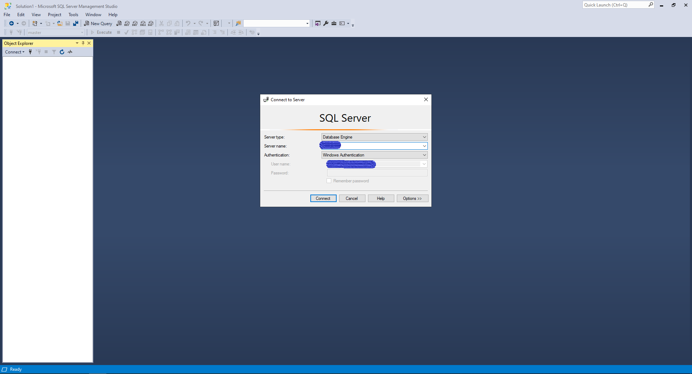

# Deployment

Deployment Folder: You will get file that contain the application file and the script for the database.

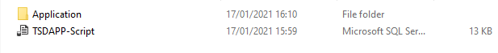

1. First you need to open the script that called “TSDAPP-Script”,

It will open in SQL server management studio, you will need to execute the script.

1. After the script is executed successfully you can close the SQL server management studio program.

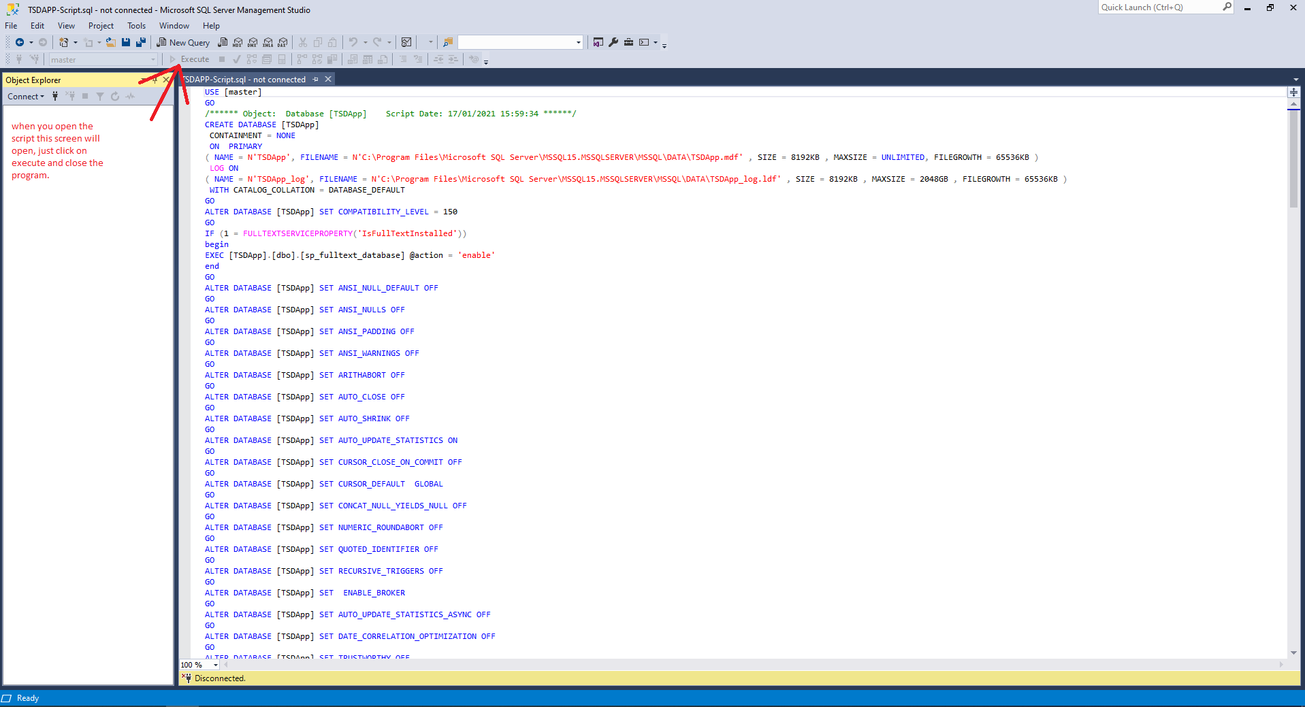

# Configuration

Set up your connection string:

1. First you need to open the folder called Application”.



You will find these files

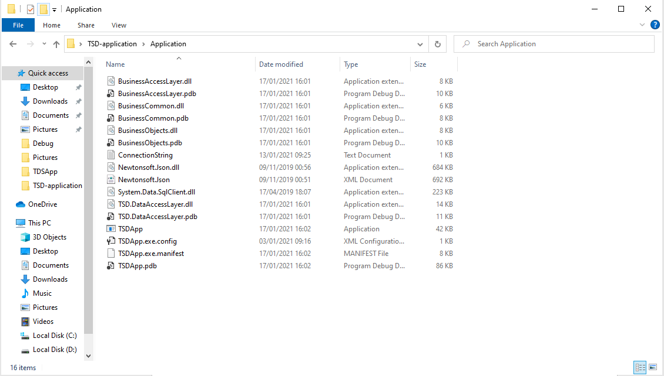

1. Now we are going to update the “ConnectionString.txt” file, you need to set up your own connection string to database.
2. Open the file called “ConnectionString.txt” and put your own data in it as it shown below:

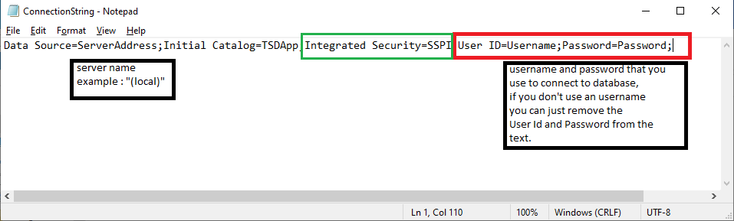

Fields to change:

1. Server Address: set your server address (Machine Name /IP) on which the DB is created.
2. Username: use the username that has access on SQL server instance.
3. Password: use the password for the user that has access on SQL server instance.

Note: if you use windows authentication (integrated authentication) remove the section within the red rectangle in the picture above.

Note: if you use SQL server authentication (username and password) remove the section within the green rectangle in the picture above.

# User Interface

Open the Application called “TSDApp.exe” within the files below



The app will start after double click on it and you will see the main form

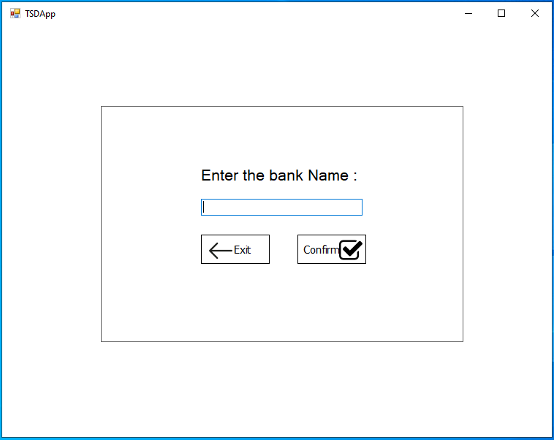

In this form you can either create a new bank or login to your bank if exist:

1. It will automatically create a new bank if the bank name does not exist before, to do that you can easily write the bank name in the textbox and click on confirm button.
2. You can login to your old bank by using the same name you used before
3. Click on confirm button.
4. Exit button: used to exit the application.

After entering the bank name and click confirm this form will be shown:

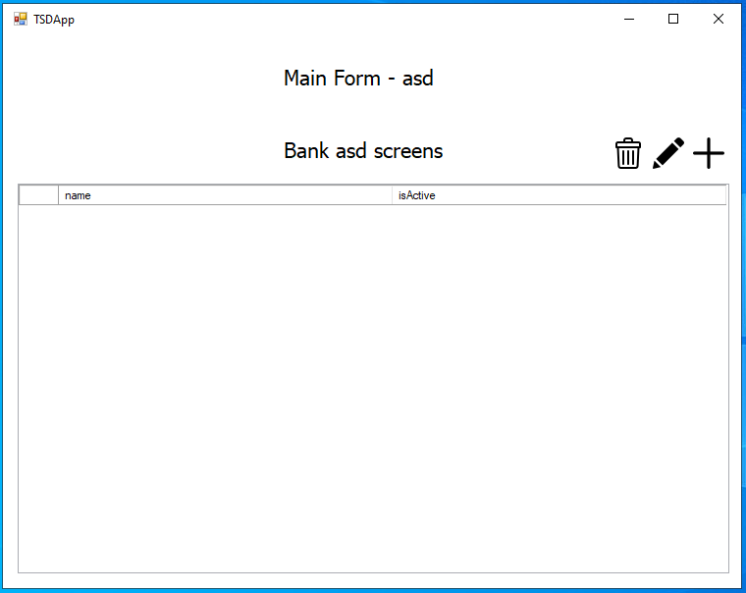

* You will see the bank name on the top of the form.
* You can see your screens in the grid view (if there is).
* You can add a new screen by clicking on the icon, you will see how to do in action.



* You can edit a screen that already exist by clicking on the icon, you will see how to do this in action.



* You can delete one or more screens that already exist by clicking on the C:\Users\Moayad\Documents\GitHub\TDSApp\TSDApp\TSDApp\Resources\trash(1).png icon, you will see how to do this in action.

## Add Screen

After clicking on C:\Users\Moayad\AppData\Local\Microsoft\Windows\INetCache\Content.Word\plus.png button this form will be shown:

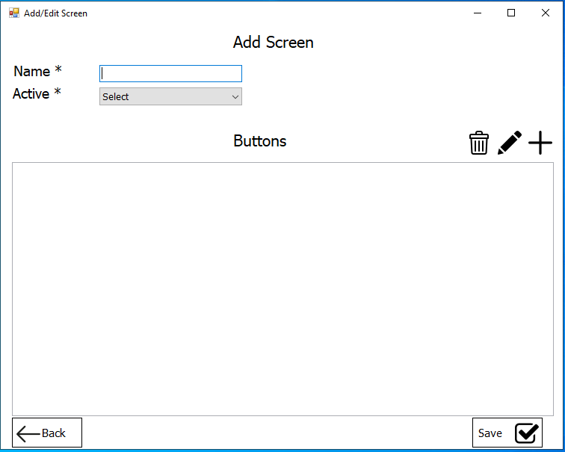

* You can enter the screen name in the textbox, and select if you want to active this screen or not. (* only one screen can be active at the same time).
* You can see buttons related to this screen in the grid view (if there is).
* You can add a new button by clicking on the C:\Users\Moayad\AppData\Local\Microsoft\Windows\INetCache\Content.Word\plus.png icon, you will see how to do in action.
* You can edit a button that already exist by clicking on the C:\Users\Moayad\AppData\Local\Microsoft\Windows\INetCache\Content.Word\draw.png icon, you will see how to do this in action.
* You can delete one or more buttons that already exist by clicking on the C:\Users\Moayad\Documents\GitHub\TDSApp\TSDApp\TSDApp\Resources\trash(1).png icon, you will see how to do this in action.
* Save button: to save the screen after adding buttons or modified the screen (screen and it buttons will be save together).
* Back button: to go back to the main form, but no changes will be save to the database.

Note: You can save the screen only if it the screen contain at least one button

## Add a Button

1. After clicking on C:\Users\Moayad\AppData\Local\Microsoft\Windows\INetCache\Content.Word\plus.png icon this form will be shown:

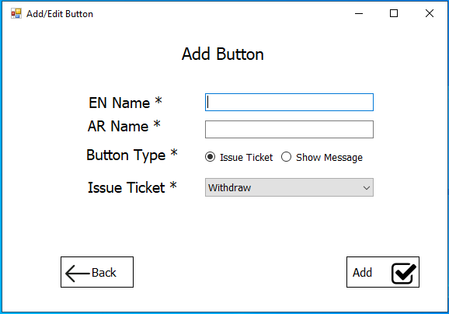

* Here you can add the button details, and select the type of button, if you choose the “Show Message” radio button the form will be like this:

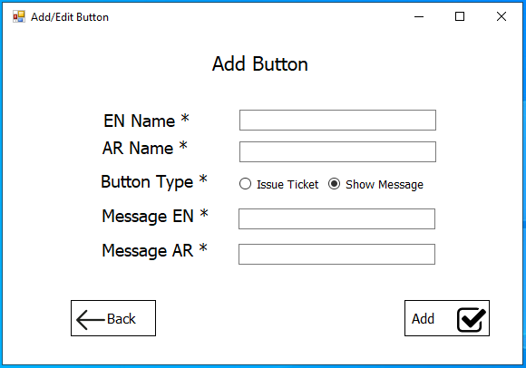

1. After filling the information for this button you can easily click on Add button to add the button to the screen and this form will closed and the screen form will open as show below:

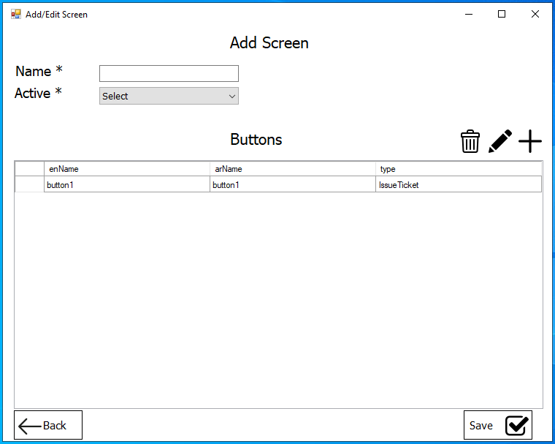

1. You can now fill the screen name and active mode and click on save button to save the screen. After that you will be automatically back to the main form where all screens are shown:

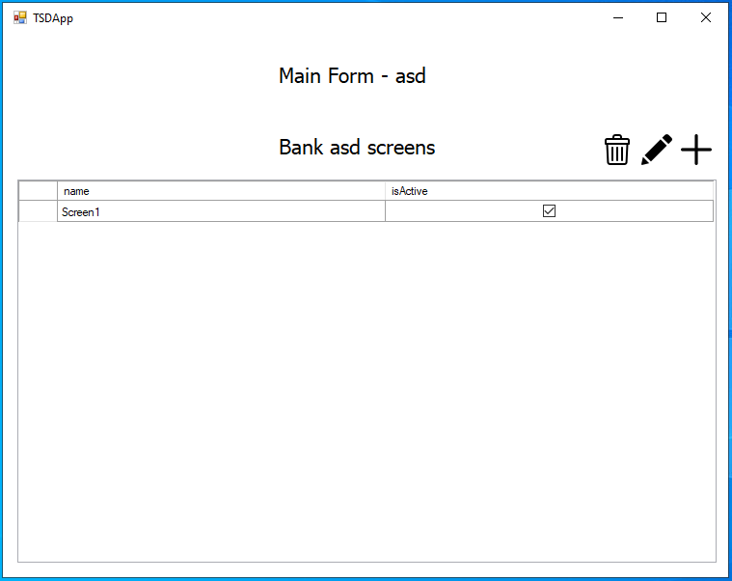

## Edit a Screen

To edit a screen you easily select the screen that you want to edit, after select the screen you can click on the C:\Users\Moayad\AppData\Local\Microsoft\Windows\INetCache\Content.Word\draw.png icon as show below

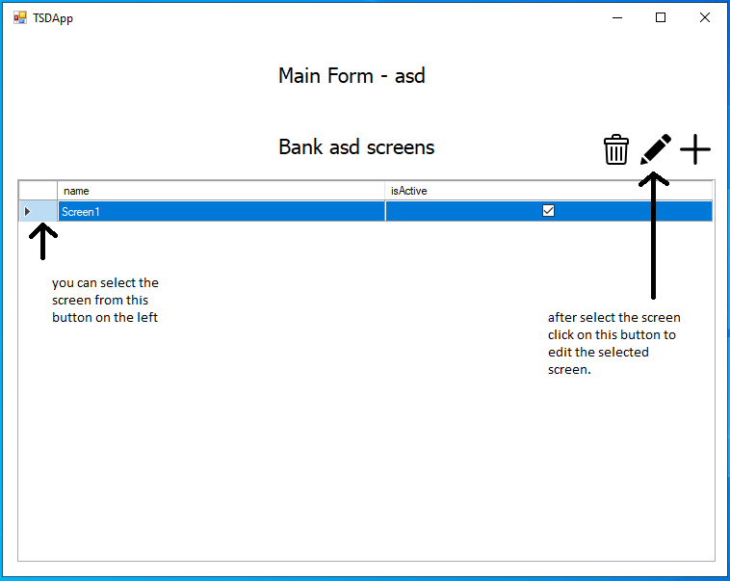

In this form, you will see the screen details and the buttons that were added previously as shown below

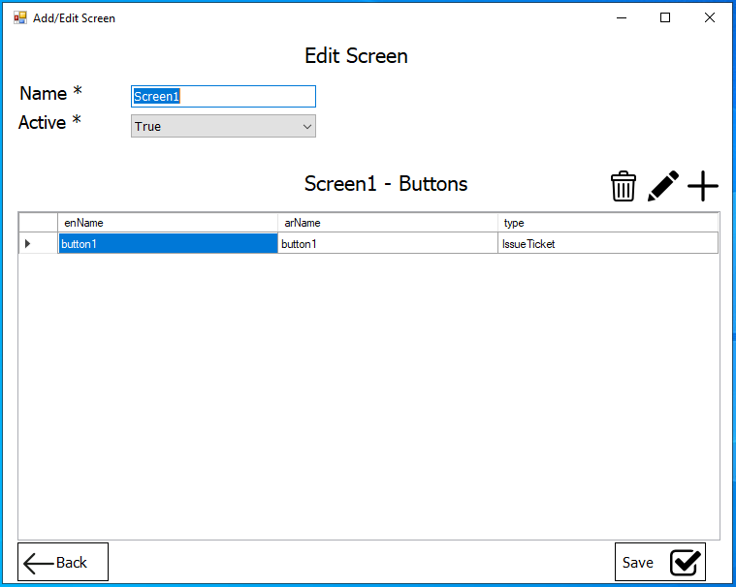

* You can now see the button in the grid view and the details for the screen (screen name and active mode).
* You can Add, Edit or Delete buttons and modified the screen details and save the screen.

**Ticketing Screen Designer Application/ Desktop Application**

## Edit a Button

1. You can edit button from the screen form by selecting the button as you see before and click on the C:\Users\Moayad\AppData\Local\Microsoft\Windows\INetCache\Content.Word\draw.pngicon on the top right of the form as show below

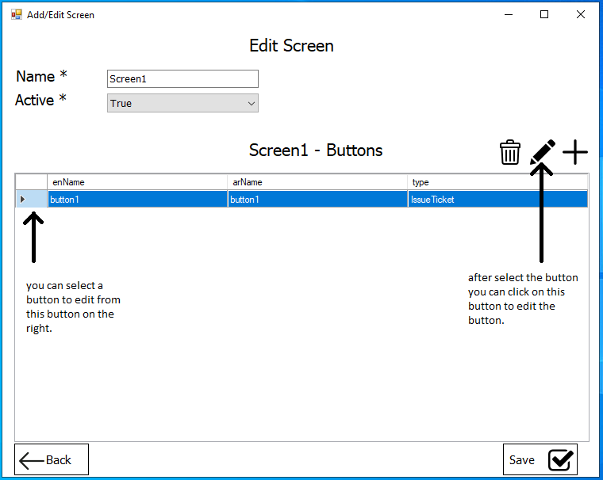

1. After that you will see a button form that fill with button details you can modified the details and save the button by clicking the edit button:

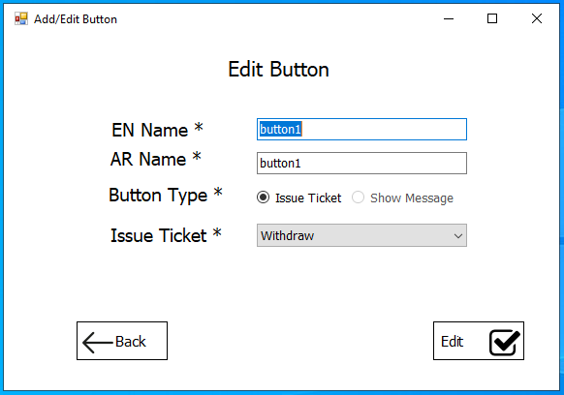

* You will be return to the previous form with the changed data and

## Delete a Button

1. You can delete button from screen by selecting the button and click on the C:\Users\Moayad\Documents\GitHub\TDSApp\TSDApp\TSDApp\Resources\trash(1).png button.
2. The button will be deleted from the grid view and from the database.

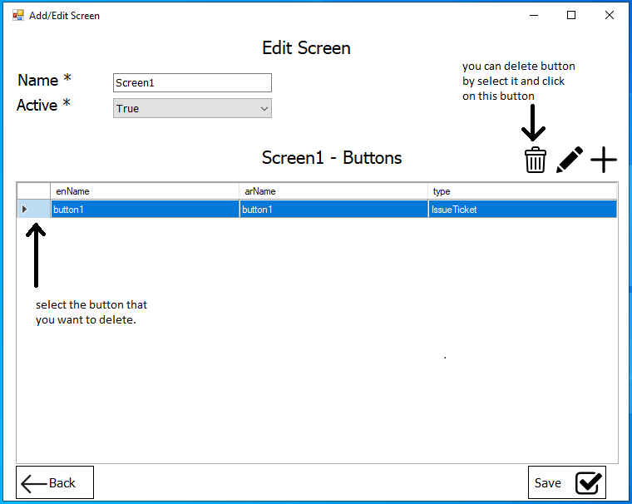

1. Confirmation message box will appear to confirm deleting the button:

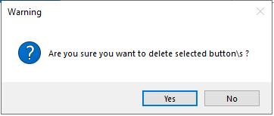

**Note: You can select multiple buttons to delete them at the same time.**

## Delete a Screen

1. You can delete a screen from screen by selecting the screen and click on the C:\Users\Moayad\Documents\GitHub\TDSApp\TSDApp\TSDApp\Resources\trash(1).png icon.
2. All the buttons related to this screen will be deleted.
3. The screen will be deleted from the grid view and from the database.

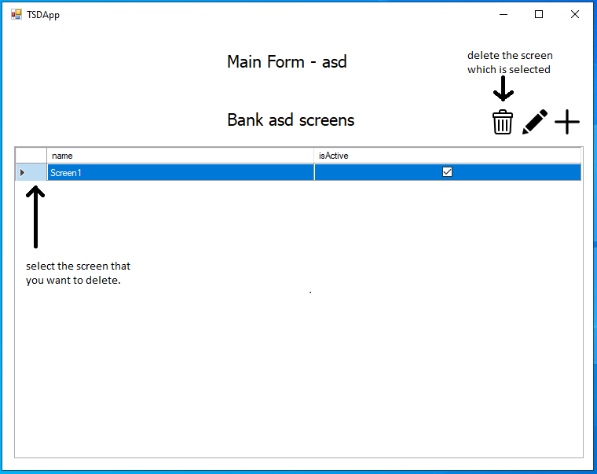

1. Confirmation message box will appear to confirm deleting the screen:

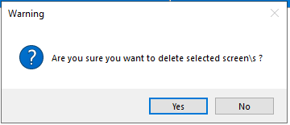

**Note: You can select multiple screens to delete them at the same time.**

# Warning Messages

## Warning that maybe occurred

* If this warning shows up you must check “ConnectionString.txt” file and make sure that your connection string is right.

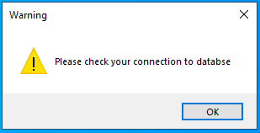

* If this warning shows up that means someone already delete the button you are trying to edit.

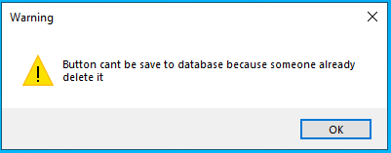

* If this warning shows up that means someone already delete the screen you are trying to edit.

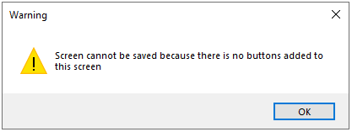

TSD-User manual

Created by: Moayad Raddad